



Data Structures & Algorithm
LAB MANUAL

Disclaimer: The content is curated from online/offline resources and used for educational purpose only
Implement a Singly Linked List

Objective:
To understand how to create a singly linked list using Python.
Equipment Required:
- Computer with Python installed, text editor/IDE.

Prerequisites:
Basic knowledge of classes and object-oriented programming.
Problem Statement:
Write a program to create a basic singly linked list and traverse it to display all elements.

Procedure:
- Define a Node class with data and next.
- Define a LinkedList class with head initialized to None.
- Create and link nodes manually.
- Write a method to traverse and print the list.

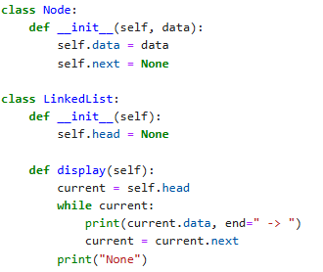
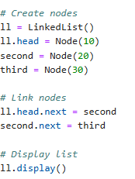

Output:

